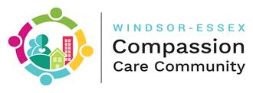

**WECCC 2019 Program Evaluation Highlights**

The Windsor Essex Compassion Community (WECCC) is a community system to improve population health, wellness and quality of life through prevention, screening, intervention, community development, volunteerism, and feedback. WECCC:

1. **Educates** the public on the importance of being connected
2. **Screens** people to identify social risks to health and to prompt early action
3. **Intervenes** to improve the lives of high risk or vulnerable individuals and families by providing 1:1 **connection support** to help them achieve their goals
4. Engages the whole of community in **opening doors** and **developing new opportunities** to address the aspirations and needs of groups of individuals
5. Recruits and **trains** community volunteers, students and partner organizations.
6. Provides **feedback** at multiple levels, measures progress, and reports real-time impacts on population health and quality of life

WECCC benefits people who are isolated or vulnerable, caregivers, and the general public.

**In 2019, WECCC’s small project team (<5 FTEs) and mighty group of volunteers have helped to improve the quality of life of more than 2,500 citizens of Windsor and Essex county.**

* Over 540 high risk and vulnerable individuals and families are now better connected with the community. 222 new individuals received active 1:1 connections support in 2019

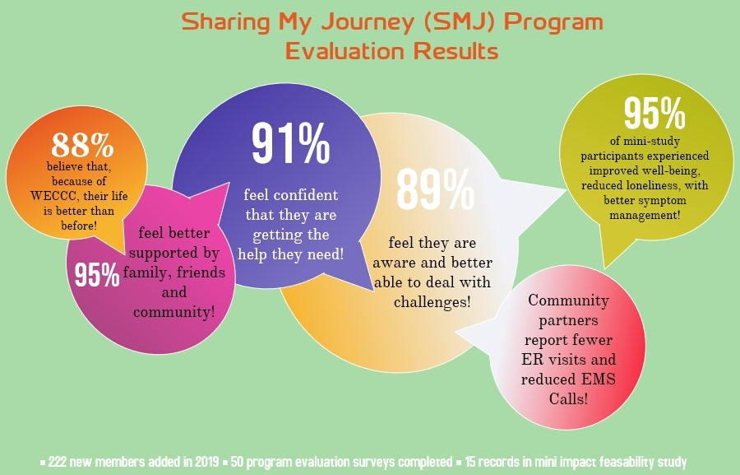

* 320 members who joined WECCC previously receive check-in support
* Over 2,000 people are now educated about the importance of being connected and future wishes, including 1,100 individuals who received personalized quality of life feedback and community connection suggestions as part of our loneliness screening and outreach program
  + 95% of workshop participants highly satisfied
* WECCC received quality of life data for 1,094 new individuals in 2019. To date, 2,300 quality of life data records have been collected.

**WECCC trained, supervised and mentored 101 new community volunteers.** Our community volunteer team has grown to 41 regular volunteers, plus 38 local volunteers engaged through community hub partners. WECCC PMO additionally supervised 22 student placements and trained a wide range of community partners to join the WECCC movement and use our processes and tools within their own programs, through a train the leader approach.

**WECCC is building more capacity in the community by working with local champions in 4 new geographies to spread Compassion hubs more widely throughout Windsor and Essex county; and partnering with 65 community organizations who are directly supporting the WECCC movement at a number of different levels**

**The Human Impact Factor**

* Saving lives
* Getting lives back on track
* Helping people who are vulnerable achieve basic dignity
* Helping people who are isolated find new friends and companionship
* Making it possible for people to do more of what they love to do
* Helping people feel comforted and even loved
* Bringing people and families together
* Supporting people and families at end of life and dealing with grief

**Filling in the Gaps with Practical Help-** *What kind of connections can WECCC help make?*

Virtually anything that will achieve a person’s goals and improve their life. We have helped people find activities they love to do, reach out to meet other people, learn to ride a bus, get their paperwork sorted out, find jobs, housing, furniture and places to get food, develop their own plans for self-care, build a ramp to get outside, get their car fixed, find opportunities to use their time and talents to help others, and many more things. We have helped people actively thinking about suicide get help.

**Social and Technical Innovation**

WECCC has developed, tested and is delivering a wide range of programs, activities, and tools communities can use to improve population health, wellness and quality of life.