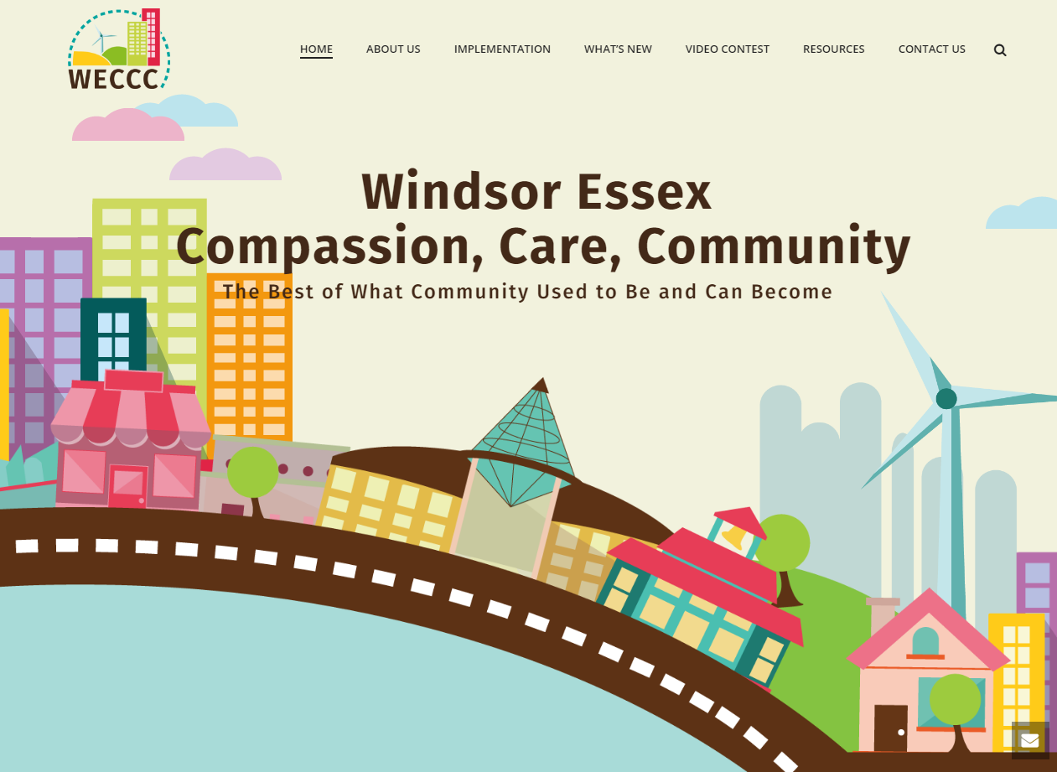

WECCC 2019 ANNUAL REPORT SERIES
Volunteer and Community Partnership Training

Highlights
The Windsor Essex Compassion Care Community (WECCC) is creating new opportunities for community connection through formal training and supervision for students and community volunteers, and through training and mentorship of community leaders and agency staff. In 2019, WECCC trained, supervised and mentored 101 new community volunteers. Our community volunteer team has grown to 41 regular volunteers, plus 38 local volunteers engaged through community hub partners. WECCC PMO additionally supervised 22 student placements and trained a wide range of community partners to join the WECCC movement and use our processes and tools within their own programs, through a train the leader philosophy.

A. Volunteer Recruitment and Training
WECCC is creating new opportunities for community connection, through formal training and supervision for students and community volunteers. WECCC volunteers are incredibly motivated and diverse in terms of age, culture, and backgrounds. Access to more flexible volunteer opportunities is itself health promoting for the volunteers as well as the beneficiaries.

i. Community Connector Volunteers
The WECCC team is supported by 41 community volunteers. In 2019, WECCC recruited and trained 30 new community volunteers, including 23 currently in the process of being trained as of December. 11 volunteers recruited previously are still active (41 volunteers total). We hosted 3 training sessions: 1- 3 hour training, 2- 6 hour trainings for volunteers. Community volunteers support the following WECCC programs: SMJ (8), IBC (12), Admin (3), Phone support (2), Research (1), and Communications (2). WECCC SMJ and IBC volunteers contributed 334 hours of community service to these programs.

In addition, WECCC satellite Compassion hubs are in the process of recruiting and training their own community volunteers:
- Assumption Cares - 35
- Amherstburg Cares- 3
ii. Student Placements
In 2019, WECCC provided 22 community placement and internship opportunities for students from various interprofessional disciplines, including:
- Social Services Worker program, St Clair College (4 students)
- Social Work, University of Windsor (4 students)
- Nursing, University of Windsor (4 students)
- Summer students – Canada summer jobs (10 students)
(Total students = 22)
As of December 2019, 4 students are currently active with WECCC.

WECCC students contributed 7,964 hours of service to WECCC to achieve learning objectives (or 362 hours on average per student placement)

iii. Education Sector Events - Student Learning and Volunteer Promotion
As part of our volunteer recruitment efforts, WECCC staff attend a variety of public and educational events to inform people about WECCC, including opportunities to volunteer.

January 16 – University of Windsor, Intro to Nursing – Approximately 200 students
WECCC was invited to speak to first year nursing students about Community-Based care for seniors. Students learned what a compassionate community is and the shift to community-based, holistic care. The harmful effects of social isolation and loneliness on seniors were discussed along with the benefits of social connections.

April 23 – What is Community? - Catholic Central High School – 25 Students
Students enrolled in the English as a Second Language (ESL) program consisted of 25 new Canadians. WECCC was invited to share with the students what a community is, why compassion is so important, and the benefits of making social connections.

May 1, 2019 – St. Clair College - Celebrating Black Excellence
This event took place at St. Clair College where 60+ Black high school students from the Windsor area were there to gain insight into different professions and career options. WECCC had direct conversation with nearly two dozen students considering to transition from high school to secondary education or to entrepreneurship. Conversations were around what is WECCC, what the project management team does, how it impacts the community, who is involved, why the movement exists, how students can get involved and what it means to work in public relations.

June 2019 – Canadian College
Education provided to Personal Support Worker Students – background of WECCC and “The Importance of Being Connected”. 14 individuals were in attendance. Several individuals in attendance indicated that this important information for them in order to support individuals that they serve to be connected!

September 26, 2019 - Windsor – Lancers Care Volunteer Fair
A table at this fair provided the opportunity for exposure to nearly a thousand students who are interested in volunteering their time to support community service organizations. Our WECCC team spoke with 30 interested students and had 20 surveys completed.

October 17, 2019 – St. Clair College Social Service Worker – Gerontology
“The Importance of Being Connected” education provided to 74 students. This information is useful for them to know when working with senior in the various career paths that these individuals will undertake. 2 volunteers were recruited from this group.

October 22, 2019 – Windsor - St. Clair College Volunteer Fair
A table at this fair provided the opportunity for exposure to nearly a thousand students who are interested in volunteering their time to support community service organizations. WECCC staff spoke with 50 students and 30 vendors about our program.

November, 2019 – University of Windsor – 4th Year Nursing Students
28 students attended education on the background of WECCC and “The Importance of Being Connected”.

November 2019 - Canterbury Elder College
Canterbury Elder College provides education to seniors on various topics of interest to them. Presentation provided on the background of WECCC and “The Importance of Being Connected” to 8 individuals.

B. Compassion Hub Training
Geographically-based Compassion Hubs offer a wide range of WECCC services, public wellness and education activities, and engage local partners to co-design their own local solutions and create new opportunities. Based on a “Train the Leaders” philosophy, WECCC is training hub partners to promote the WECCC movement within their organizations, and make WECCC tools and processes available to citizens within their geographies.

i. Assumption Cares
Our Lady Of Assumption Church – October 2019
“Intro to WECCC” and “Importance of Being Connected” presentations were provided. A meeting is planned for next phase planning which includes surveys and sharing my journey.

ii. Amherstburg Hub
Amherstburg Active & Aging Well Expo - June 7-8
Hosted at the Libro Centre, this event provided the opportunity for brand awareness. This event is targeted towards seniors and was not well attended. WECCC did, however, make some great connections with other community organizations that were tending to their booths. These connections resulted in meetings and conversations to discuss partnerships or working together.

Amherstburg Community Services –August 2019
“Intro to WECCC” and “The Importance of Being Connected” information was provided to staff and volunteers of ACS. As a result of this presentation the staff is using and distributing surveys. As a result the agency is conducting the survey with individuals who attend programming and also during the intake process.

Amherstburg Family Health Team – October 2019
A lunch and learn was provided for 15 staff which covered the “Intro to WECCC” and “The Importance of Being Connected”.

Amherstburg Community Church – December 2019
A presentation was provided on “The Importance of Being Connected” and “Intro to WECCC”. As a result 3 people will take the training in the New Year. Additionally, representatives from Lighthouse Church attended this session and agreed to become involved in the Compassion Amherstburg movement.

St. Andrew’s Presbyterian Church – Amherstburg – November, 2019
Presentation provided to interested volunteers – WECCC principles and purpose along with “The Importance of Being Connected”. As a result 3 volunteers have been recruited. Training in progress.

iii. Tecumseh Hub
Tecumseh Town Council - WECCC background and summary of the effects of Loneliness provided to Tecumseh Town Council and invitation to take part in WECCC.

C. Community Partner Education and Training
WECCC has developed strong working relationships with a wide variety of service agencies, and provides practical training to staff and agency volunteers on the aims of WECCC and how to use WECCC processes and tools to benefit their members. Highlights include:

Recurring event - The Hospice of Windsor and Essex County
Several education sessions provided at the Wellness and Welcome Centres – Windsor and Essex locations. Hospice patients, staff and volunteers have been in attendance. Education provided – background of WECCC and “The Importance of Being Connected”.

April – Huron Lodge Long Term Care facility Health Fair – Table provided with information about WECCC and “The Importance of Being Connected”. Staff and residents and families in attendance.

May 23 – City Centre Health Centre – WECCC Overview
WECCC presented to 10 healthcare professionals at the City Centre Health Centre about what WECCC is about, the tools that we use and outcomes participants experience when they make better social connections. Discussions took place on how we could work together to support people with are living with mental health challenges and/or complex needs.

May – Windsor Essex Community Health Centre – WE CHC
Presentation provided – background WECCC and “The Importance of Being Connected” to approximately 75 staff. As a result WE CHC is a referral source and WECCC has been invited to present to the Respiratory Wellness Program with resulting survey completion by attending individuals.

September 9, 2019 – Southwest Ontario Aboriginal Health Access Centre
Education about WECCC and “The Importance of Being Connected” was provided to approximately 15 staff.

October 7 - Windsor Women Working with Immigrant Women (W5)
As a kick off to Mental Health Week, WECCC was invited to present at a lunch and learn about how the Windsor Essex Compassion Care movement can help reduce social isolation. Later in October, WECCC presented the full Importance of Being Connected to staff and volunteers. In January 2020, W5 staff and volunteers will be trained on how to hold Caring Conversations with their participants, along with report follow up support.

October 2019 - Windsor Police Service
Windsor Police has agreed to share WECCC brochures with people they encounter who may be in need of services like coaching, goal setting, and workshops on how to avoid loneliness or isolation. Presentations were provided to each platoon with nearly 100 officers. Brochures were distributed to officers on the following presentation dates:
October 1st –Platoon 1
October 2nd- Platoon 4
October 4th – Platoon 3
October 7th- Platoon 2

October, 2019 – Windsor Essex CMHA
An overview of WECCC and information related to “The importance of being connected” was presented to the staff of Windsor Essex CMHA. Approximately 40 staff were in attendance. CMHA is a referral source for WECCC.

November 6 - We Trans Support
Our PMO team provided “The Importance of Being Connected” and “Caring Conversations training to WE Trans Support. The group included 17 supporting members of the LGBTQ2S community. The group was interested in learning more about loneliness and isolation specific to the transgender community. Additional training is expected to be provided by WECCC to WE Trans Support in 2020.

December - Harrow Family Health Team, Harrow
“The Importance of Being Connected” education provided to 10 individuals who have been involved in the Health Tapestry project.

Windsor YMCA
Awareness provided to staff and seniors attending exercise groups such as Osteofit, SMART exercise programming and individuals involved in seniors exercise groups. Background information provided at several sessions throughout the year on the topic of WECCC and “The Importance of Being Connected”.

Windsor Public Library and Essex County Library
Awareness provided to patrons of 21 libraries across Windsor and Essex County by providing a table with information about WECCC and “The Importance of Being Connected”

